**Christopher King**

**2018141521058**

**Mechanical Design 2**

**Class Section 01**

**09/15/2021**

# **Problem 1**

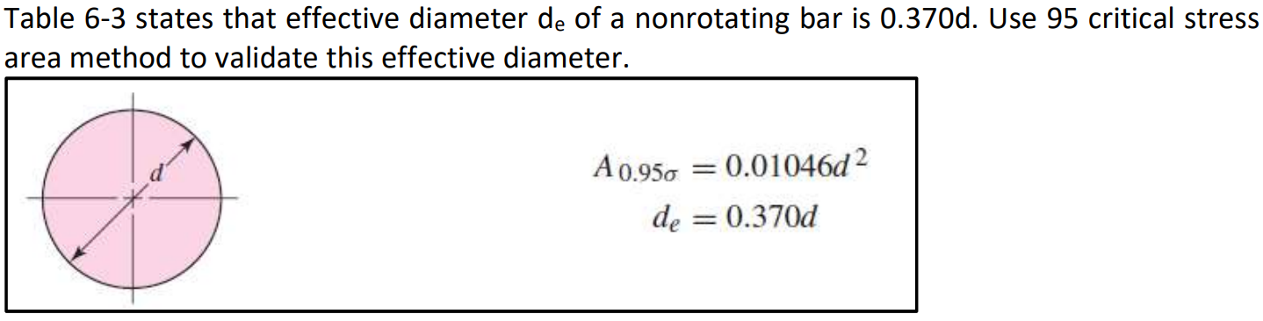

**Solution:**

For this question, we are asked to use 95 critical stress area method to validate this effective diameter of a nonrotating bar.

The effective area is equal to the twice of the dark green area as shown in Figure below.

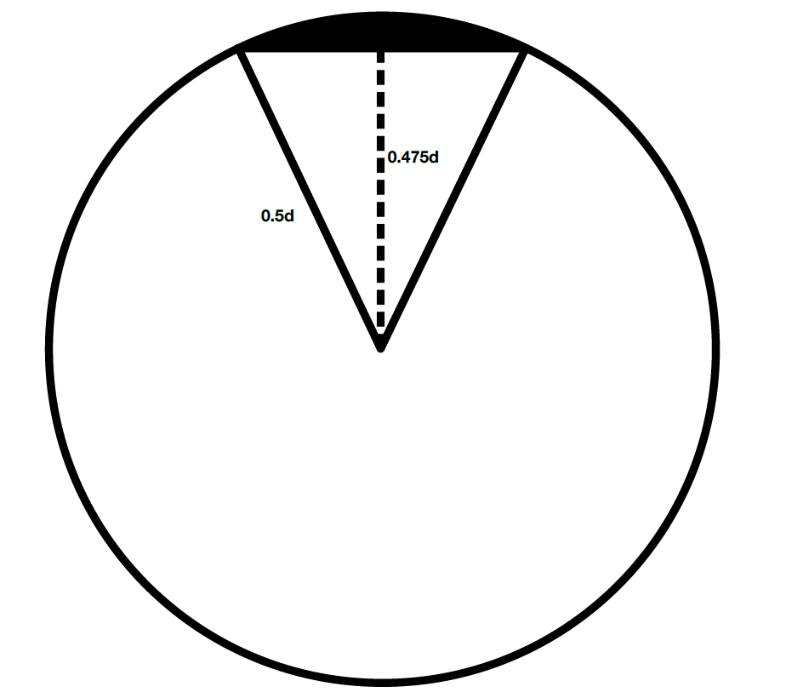

The area of the sector is equal to

The area of the triangle is equal to

Therefore, the 95% effective area is equal to

Hence, we can get the equation below:

# **Problem 2**

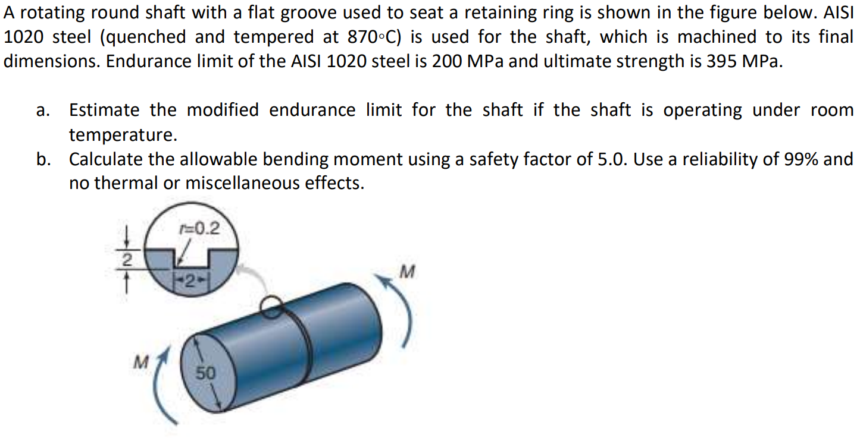

**Solution:**

1. For this question, we are asked to estimate the modified endurance limit for the shaft if the shaft is operating under room temperature.

Surface Condition (machined):

Size Effect ():

Loading Effect (bending):

Temperature Effect (room temperature):

Reliability Effect (99%):

Therefore, the modified endurance limit is equal to

1. For this question, we are asked to calculate the allowable bending moment using a safety factor of 5.0. Use a reliability of 99% and no thermal or miscellaneous effects.

According to Figure A-15-16 (, ), the stress concentration factors is equal to

The original stress is equal to

The fatigue stress concentration is equal to

Therefore,

# **Problem 3**



**Solution:**

For this question, we are asked to calculate endurance limits and modification factors of a non-rotating rectangular cross section (width=40 mm, height=60 mm. The beam is subjected to fully-reversed bending moment. As in Question 02, use AISI 1020 steel with a reliability of 99%, and no thermal or miscellaneous effects.

Surface Condition (machined):

Size Effect (, ):

Loading Effect (bending):

Temperature Effect (room temperature):

Reliability Effect (99%):

Therefore, the modified endurance limit is equal to